**Product Backlog**

***New Use Cases***

*Original User Story:* Delete or Edit Post/Comment

1. Delete Post/Comment

User Role: Administrator

Goal: To delete a post or comment.

Reason: Unsavory content finds its way on the internet in all shapes and forms, so an administrator can delete posts or comments.

Pre-Conditions: There exists a comment or post to be deleted.

Post-Conditions: The post or comment is removed from the page.

1. Edit Post/Comment

User Role: Administrator

Goal: To edit a post or comment.

Reason: An administrator may want to edit a post or comment on the site.

Pre-Conditions: A post or comment exists to be edited.

Post-Conditions: The post or comment is updated with the new content.

*Original User Story:* Post in Forum/Comment

1. Post in Forum

User Role: All above Registered User (Admin, Content Publisher)

Goal: For a user to post a reply to a forum topic.

Reason: To allow users of the site to participate in discourse.

Pre-Conditions: There exists a forum topic to post a reply to.

Post-Conditions: The reply is posted and is available for viewing in the forum.

1. Comment on Content

User Role: All above Registered User (Admin, Content Publisher)

Goal: For a user to comment on posted content.

Reason: To allow discussion on site content.

Pre-Conditions: There exists some content to reply to.

Post-Conditions: The reply is visible on the site when viewing aforementioned content.

**All Use Cases (Revised)**

|  |
| --- |
| ***Use Cases***  1. Post Content Link User Role: Content Publisher Goal: To post a link to an article hosted on a 3rd party website. Reason: To provide users with content relevant to the elections and local news. Pre-Conditions: Content publisher is logged in, an article has been found, and a link is available to the content.  Post-Conditions: The link is posted to the website and available for users to view. |
| 2. Post Content  User Role: Administrator, Content Publisher Goal: To post content for all users to view. Reason: To provide users with well-presented media for consumption. Pre-Conditions: Content publisher or administrator is logged in, and has content to post. Post-Conditions: The content is posted and is available for viewing. |
| 3. Update Live Coverage  User Role: Administrator Goal: To post real-time updates of the electoral process. Reason: So users can enjoy and stay informed with up-to-the-minute updates.  Pre-Conditions: Account with administrator permissions is logged in. Post-Conditions: The update is pushed out live to all viewers on page. |
| 4. Comment on Content  User Role: All above Registered User (Admin, Content Publisher)  Goal: For a user to comment on posted content.  Reason: To allow discussion on site content.  Pre-Conditions: There exists some content to reply to.  Post-Conditions: The reply is visible on the site when viewing aforementioned content.  5. Post in Forum  User Role: All above Registered User (Admin, Content Publisher)  Goal: For a user to post a reply to a forum topic.  Reason: To allow users of the site to participate in discourse.  Pre-Conditions: There exists a forum topic to post a reply to.  Post-Conditions: The reply is posted and is available for viewing in the forum. |
| 6. Create Forum Topic User Role: Administrator Goal: Create a new topic. Reason: To provide a forum for users to post in. Pre-Conditions: There is not an identical forum topic. Post-Conditions: Users can now post content inside of the topic. |
| 7. View Content User Role: Administrator, Content Publisher, Registered User, Unregistered User  Goal: Allow all users to view content posted. Reason: To see content that other users have posted. Pre-Conditions: Content has been posted. Post-Conditions: Users can respond to post, Administrator can edit and delete posts. |
| 8. Create Account User Role: Unregistered User Goal: Allows user to create their own personal account. Reason: To allow users to join and contribute to the community. Pre-Conditions: User does not have an account. Post-Conditions: User now has access to privilege given to their user class. |
| 9. Update Map Data User Role: Administrator Goal: Designate points on map that link with stories. Reason: To provide users an easy way to view the location to which a story is connected. Pre-Conditions: A story has been posted. Post-Conditions: A point on the map is linked with the story. |
| 10. Delete Post/Comment User Role: Administrator  Goal: To delete a post or comment.  Reason: Unsavory content finds its way on the internet in all shapes and forms,  so an administrator can delete posts or comments.  Pre-Conditions: There exists a comment or post to be deleted.  Post-Conditions: The post or comment is removed from the page.  11. Edit Post/Comment  User Role: Administrator  Goal: To edit a post or comment.  Reason: An administrator may want to edit a post or comment on the site.  Pre-Conditions: A post or comment exists to be edited.  Post-Conditions: The post or comment is updated with the new content. |
| 12. View Analytics User Role: Administrator Goal: View analytics about the website such as demographics and page views Reason: To give administrators meaningful statistics about the website. Pre-Conditions: Analytics have been collected and administrator is logged in. Post-Conditions: The administrator is able to view analytics. |

|  |  |  |  |  |  |  |
| --- | --- | --- | --- | --- | --- | --- |
| **Fibonacci Distribution** | | | | | | |
| **1** | **2** | **3** | **5** | **8** | **13** | **21** |
| Delete Post/Comment | Post Content Link | View Analytics | Post Content | Comment on Content | Update Live Coverage | Create Forum Topic |
| Edit Post/Comment |  |  | Post in Forum | Update Map Data | Create Account | View Content |
| **Total** | | | | | | |
| **106** | | | | | | |
| **Target Sprint** | | | | | | |
| **36** | | | | | | |

**Selected User Stories – First Iteration**

|  |  |
| --- | --- |
| **Story** | **Value** |
| 1. Post Content Link | **2** |
| 7. View Content | **21** |
| 8. Create Account | **13** |
| **Total** | **36** |

***Methodology***

In order to meet the pre and post conditions of all three of these user stories, we must provide a bare-bones version of the site. This first iteration will have a workable user interface that allows a user to view content and create an account. We will have account levels partially implemented, starting with the administrator account to allow the posting of a content link to the site. The user interface will be developed using placeholder text and images, as implementing these will come at a later iteration. This functionality will provide us the base system to build the rest of the application on.

**Rough Interface Design Sketches**

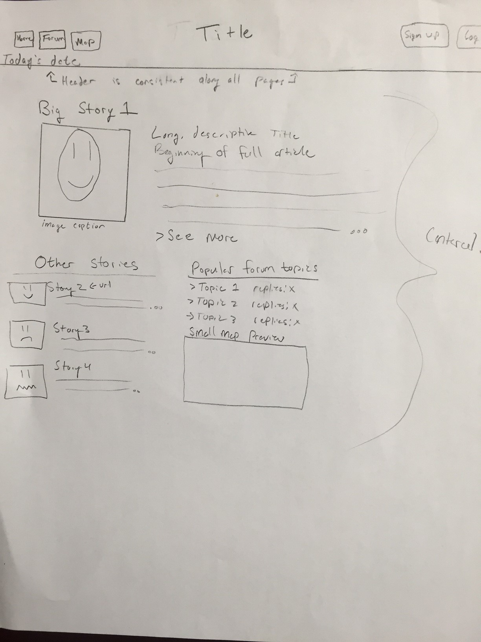Homepage

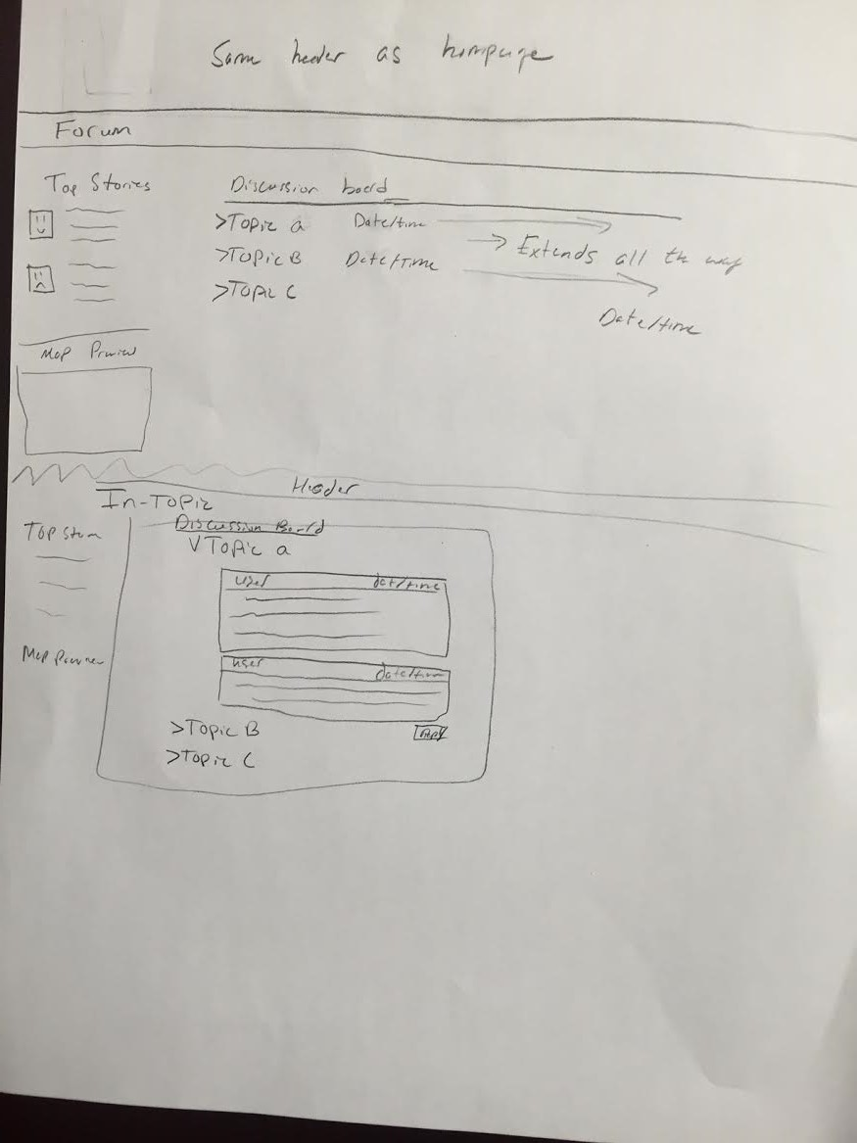Forum / Out of topic on top, in topic on bottom.